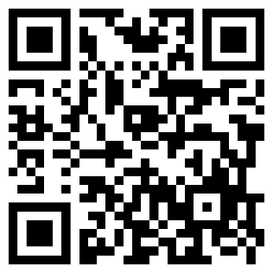
IF I AM FULL,
EMPTY ME!!
Tool Page
For I yearn to be clean.
Instructions: Wear a mask for dust. Lift the upper black latches on both sides of the waste container. Remove the bottom latch. Remove the top, dump the dust in the bins outside, replace latches.

