Your first laser project

Context
The purpose of this tutorial is to provide a “next step” after your induction.
The tutorial provides a very simplified file preparation workflow, as the focus is on re-enforcing the overall workflow described in the induction and going deeper into the details of using Ruby.
This tutorial uses:
- A preload file – First project.svg
- Inkscape – free to download and install, already installed on the Makerspace laptops
- Ruby – installed on the Laser PC (very difficult to install on your own laptop)
If anyone would like to provide instructions for doing the file preparation steps in Adobe Illustrator or CorelDRAW, I’m happy to add them to the tutorial.

Step 1: File preparation
See the visual guide at the end of this document. I kept the images separate to keep the text compact.
- Open First project.svg in Inkscape
- Type your name
  - Select the Text tool
  - Double click on YourName to select all the text
  - Type your name to replace YourName
- Adjust the layout
Only if the offset around your name doesn’t join all the letters together well.
  - Select all the letters or just those that don’t join
  - Reduce space between letters until they are fairly close together, but not touching
- Position the loop
  - Select both circles
  - Move them to overlap it appropriately with the first letter of your name
- Save the file to preserve an editable version
The next step will destroy the editable text, so you want to keep a version that you can change if you need to.
  - File / Save as - YourName edit file
- Save the file for final editing for laser cutting
This will give you a file to import into Ruby
  - File / Save As – YourName cut file
- Prepare the text for cutting and engraving
The current file is not suitable for Ruby.
You want the letters to be engraved fully, so you need a black fill (Ruby default for engrave).
  - Use the arrow tool to select the text
  - Change the fill colour to black (left click on palette at the bottom of the screen)
  - Change the stroke colour to None (shift click on the X in the palette)
- Merge the keyring hole with the offset
  - Select the offset outline
  - Path / Object to path
  - Shift + click on the outer circle of the keyring hole so that it and the offset are selected
  - Path / Union
- Set the outline for cutting
  - Select the outline and the inner circle
  - Set the fill to None
  - Set the stroke to red (Ruby default for cut)
- Adjust the outline
Depending on the letters of your name, you may have strange paths or tiny holes in the outline.
  - Select the outline
  - Use the Zoom tool to zoom in on parts for adjusting/deleting
  - Use the Edit paths by nodes tool to select and adjust/delete nodes
- Adjust the page
You should make the page the same size as the object as this makes it easier to work with in Ruby
  - Select the keyring outline
  - File / Document properties
  - Resize page to content
  - Resize page to drawing or selection
- Save
You now have 3 files:
- First project.svg – unchanged
- YourName edit file.svg – editable version (change text, text layout and position of the ring)
- YourName cut file.svg – ready for Ruby

Step 2: Review your induction
- Download the induction presentation (See the Laser Induction PDF link on the Laser Tool Page) and refresh your memory of the overall workflow
- Make sure you have your Ruby password (you can’t recover it unassisted)
- Put your edit and your cut files on a memory stick
- Book the laser

Step 3: Cut and engrave
- Prepare the laser
  - Perform all the maintenance steps
- Activate Ruby
  - Open Ruby from the Start menu
  - Make sure it is active in the Notification icon
  - Login
- Design (import the cut file)
  - Go to the Design screen
  - Import design
  - Select and open your file
  - Select the file on the left sidebar
  - Because you made all the necessary changes in Inkscape, there is nothing more for you to do on this screen
  - Create job
- Prepare (to cut and engrave)
  - Position the sheet of 2mm or 3mm ply
  - Focus the laser
  - Align the keyring with the cross hairs (the origin is top left)
  - Choose the material - First project 2mm or First project 3mm
  - Push to laser
- Produce
  - Press Play
- Wrap up
  - Perform maintenance
  - Tap fob
  - Logout of Ruby
  - Shut down laser
  - Shut down Laser PC

Visual guide to file preparation
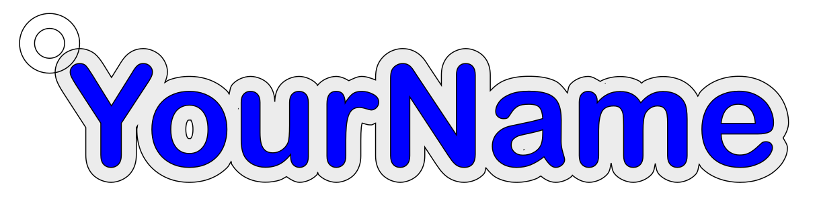
1. Open First project.svg in Inkscape
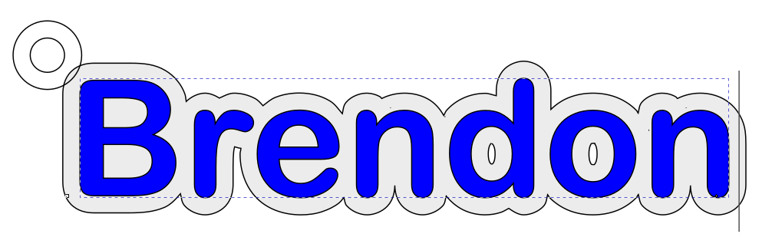
2. Type your name
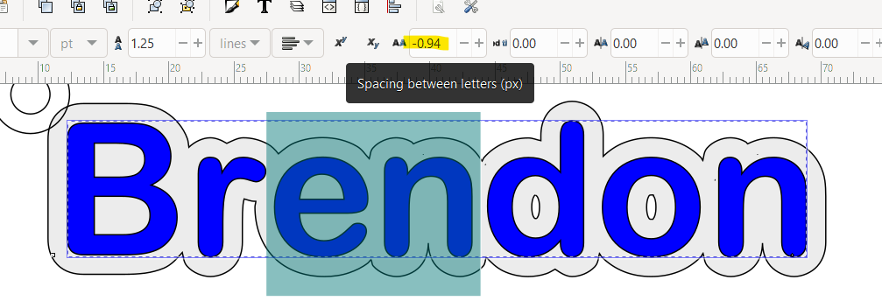
3. Adjust the layout
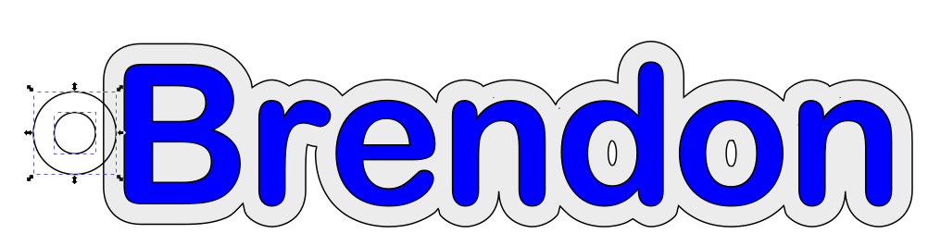
4. Position the loop
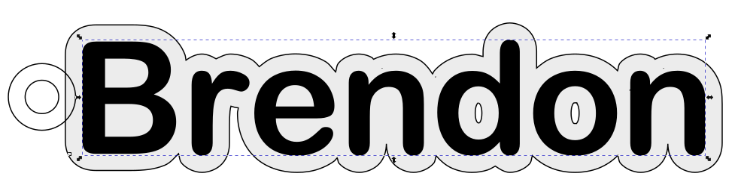
7. Prepare the text for cutting and engraving

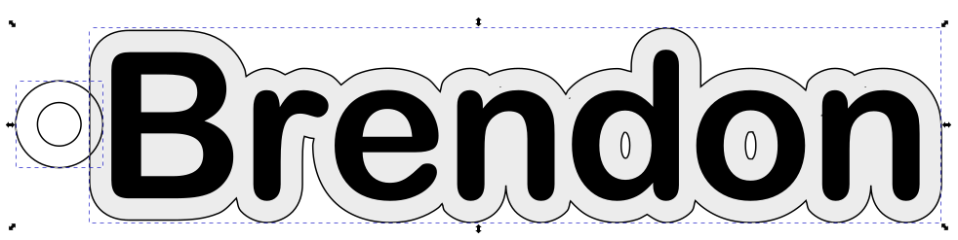
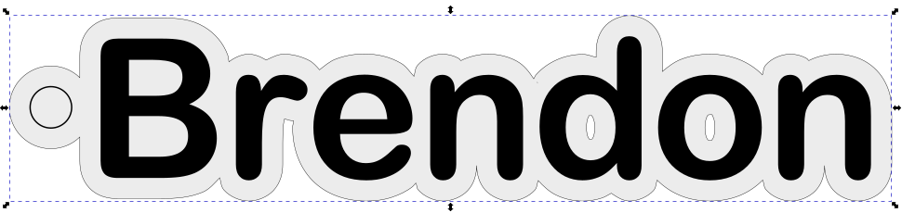
8. Merge the keyring hole with the offset
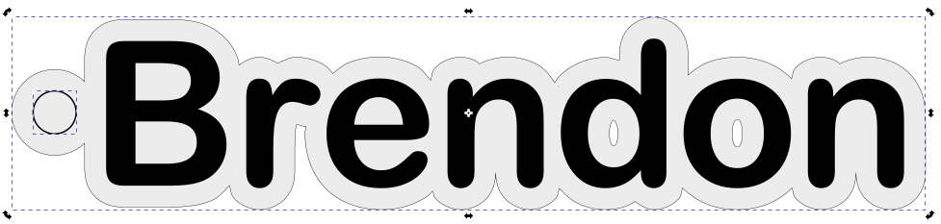
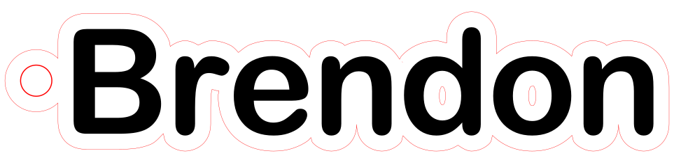
9. Set the outline for cutting
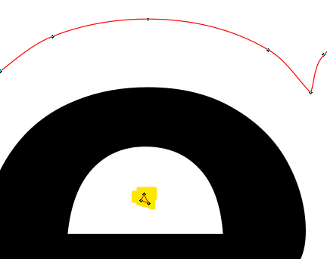
10. Adjust the outline
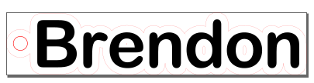
11. Adjust the page

