GFRC Mix DesignBy Brandon Gore
Part one of a two-part series on glass-fiber reinforced concrete
Let’s start at the beginning: What is GFRC, what are its benefits and what are its downsides?
GFRC stands for glass-fiber reinforced concrete. The GFRC I use is a composite of portland cement, silica sand, Forton VF-774 (an acrylic admixture), Liquefaction Compound (a dry plasticizer specifically formulated by my team for use in GFRC), Vitro Minerals VCAS-micronHS (a pozzolan that adds strength and helps to decrease porosity), water, and alkali-resistant chopped glass-fiber strands. Combine these ingredients and you have an extremely strong, ductile, easily formable material that excels in architectural precast applications.

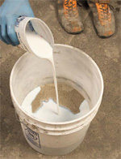
Sprayable face coat, Step 3: Adding acylic emusion.
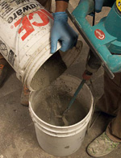
Sprayable face coat, step 6: Cement must be added slowly while mixing.
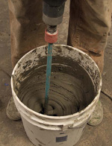
Sprayable face coat, step 8:
Mixing the face coat.
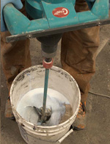
Verticle back coat, after step 3: Mixing the verticle back coat.
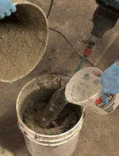
Vertical back coat, step 4: Add cement slowly while mixing. Add an additional amount of water if it is needed.
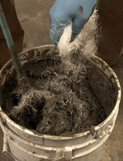
Veticle back coat, step 8: Add glass fiber while mixing slowly

GFRC pieces differs from traditional precast pieces in application techniques and reinforcement. Other than these two fundamental differences, the material reacts the same to acid staining, sealing and so on.
At the same time, the benefits of GFRC are tremendous, making it one of the hottest methods used in the creation of cutting-edge concrete pieces. GFRC weighs on average 30 percent to 75 percent less than comparable wet-cast. This weight savings benefits you by reducing risk of injury or damage, as well as making transportation and placement of the piece much easier.
GFRC can be cast as thin as 1 inch, opening up a world of possibilities for products and applications.
As GFRC pieces are typically cast hollow, there is no need to reinforce the mold. Mold construction time is cut in half, increasing productivity and profitability.
And there is no more need for rebar. GFRC pieces are their own reinforcement. There is no guessing on how to reinforce a complex shape. No more fussing with bending, rebending, cutting and tying rebar and wire mesh.
Since GFRC is sprayed, there is no need to vibrate the pieces, and the finish is completely smooth and bughole-free 99 percent of the time, eliminating tedious and time-consuming slurry coating and polishing.
The GFRC methods we outline here do not require expensive equipment. Most concrete artisans already own the required tools, but if not, they can be purchased from any home improvement store for a relatively low cost.
The downsides of GFRC are few, but they should be considered when bidding projects. The primary downside is exposed aggregate. GFRC is sprayed, which does not lend itself to the use of decorative aggregate. Adhering the pieces into the mold first, then spraying over the pieces, can allow for installation of limited amounts of exposed aggregate, but this can be a time-intensive process.
The ABCs of mix design
Now that we have covered the basics, let’s get to it! First, you will need to secure the following ingredients. If you need help obtaining any of these products, you may visit my supplier Web site, ConcreteApothecary.com.
• Type I/II white or gray portland cement
• No. 30 silica sand
• Forton VF-774 acrylic admixture
• Liquefaction Compound
• Vitro Minerals VCAS-micronHS
• OCV Reinforcements Anti-Crak HP 12 mm AR glass fiber
Next, you will need to gather the necessary tools. You will need:
• An air compressor rated at 15 cubic feet per minute or more. Used air compressors can be found online.
• A drywall hopper. Be sure to secure the plastic hopper bin backwards, as we typically spray down into a mold and we do not want the concrete to spill out, and use the largest-diameter tip provided with the hopper.
• A handheld mixer. We use Collomix mixers, but a high-powered drill with a paddle will work fine in the beginning.
• Plenty of 5-gallon buckets, as well as a few 20-gallon or 25-gallon plastic buckets if you can find them.
When we discuss GFRC mix designs, we talk in quarter batches. This is because we typically divide a 94-pound bag of portland cement into four equal parts. A “full batch” would be four quarter-bag batches.
The only time we ever recommend mixing a “full batch” is in the use of a self-consolidating back-coat.
Once your mold is constructed, calculate your material requirements using the following formulas:
Square footage:
Length (inches) x Width (inches) = Total square inches / 144 = Total square feet.
For 3/4-inch thick GFRC products: Number of square feet x 0.1875 = Number of 1/4-bag batches
For 1-inch thick GFRC products: Number of square feet x 0.28125 = Number of 1/4-bag batches
For 1.5-inch thick GFRC products: Number of square feet x 0.375 = Number of 1/4-bag batches
Now we will provide an overview of the three different mix designs and their respective uses.
Sprayable face coat
The sprayable face coat will form the surface of your piece, and as such, does not contain any glass fibers. You will always mix this coat first, and always in no more than a quarter batch at a time. It is very important to spray a fresh mix to achieve the highest quality-finish.
Ingredients for face coat:
• 20.5 pounds portland cement
• 3 pounds Vitro Minerals VCAS-micronHS
• 1 quart acrylic emulsion
• 2 ounces Liquefaction Compound
• 17 to 18 pounds No. 30 silica sand
Order of mixing:
1. Silica sand
2. 2 quarts chilled water (plus an extra 1/2 quart
ready for use as needed)
3. 1 quart acrylic emulsion
4. 2 ounces Liquefaction Compound
5. 3 pounds Vitro Minerals VCAS-micronHS
Mix. If using pigment, add it at this point and mix again.
6. Add cement SLOWLY while mixing.
7. Scrape sides of bucket with a trowel.
8. Mix for 45 to 60 seconds then allow concrete to rest
for two to three minutes.
9. If needed, add a small amount of water and mix again.
Vertical back coat
The second mix design is for the vertical back coat, which is used to form drop-down edges, sinks, and so on. This mix does not contain Liquefaction Compound. However, it does contain glass fibers. It is a fairly stiff mix that lends itself to not slumping. We mix this only in quarter batches to maintain a good working consistency.
Ingredients for vertical back coat:
• 23.5 pounds portland cement
• 1 quart acrylic emulsion
• 19 to 20 pounds No. 30 silica sand
• 1 pound AR glass fiber
Order of mixing:
1. Silica sand
2. 2 quarts chilled water (plus an extra 1/2 quart
ready for use as needed)
3. 1 quart acrylic emulsion
Mix. If using pigment add at this point and mix again.
4. Add cement SLOWLY while mixing.
5. Scrape sides of bucket with trowel.
6. Mix for 45 to 60 seconds then allow concrete to rest
for two to three minutes.
7. If needed, add a small amount of water and mix again.
8. Slowly add glass fiber while mixing SLOWLY. It is important to keep the mixer speed slow to prevent damaging the glass fibers.
Self-consolidating back coat
The last mix design is for the self-consolidating back-coat. This is often the last mix you will apply. The mix design generates a very wet mix that self-levels and does not require vibration.
Depending on the quantity needed, the coat can be mixed in single quarter batches or full-bag mixes.
Ingredients for self-consolidating back-coat:
• 23.5 pounds portland cement
• 1 quart acrylic emulsion
• 12 ounces Liquefaction Compound
• 19 to 20 pounds No. 30 silica sand
• 1 pound AR glass fiber
Order of mixing:
1. Silica sand
2. 2 quarts chilled water (plus an extra 1/2 quart
ready for use as needed)
3. 1 quart acrylic emulsion
4. 12 ounces liquefaction compound
Mix. If using pigment add at this point and mix again.
5. Add cement SLOWLY while mixing.
6. Scrape sides of bucket with trowel.
7. If needed, add a small amount of water and mix again
8. Slowly add glass fiber while mixing SLOWLY. It is important to keep the mixer speed slow to prevent damaging the glass fibers.
We’ve covered the benefits of GFRC, the ingredients and equipment needed, and the mix designs. In the next issue of this magazine, we’ll tackle the most important piece of the puzzle — technique.
Brandon Gore operates Gore Design Co. LLC, based in Tempe, Ariz. He can be reached at info@goredesignco.com. Training DVDs, sink molds and mold-making supplies can be found at his supplier Web site, ConcreteApothecary.com. He also offers hands-on training workshops at GFRCworkshop.com
Part two of Gore’s GRFC technique — the application process — will be published in the August issue of Concrete Decor.

GFRC ApplicationBy Brandon Gore
Part two of a two-part series on glass-fiber reinforced concrete.
In the June/July issue of Concrete Decor magazine, we covered how to put together three kinds of mixes of glass-fiber reinforced concrete. This time, we’re going to show you how to apply the GFRC after you’ve prepared it.
GFRC part one, in the previous issue, offered a lot of mix design recipes and lists. This lesson can be told mainly with pictures. Step-by-step instructions can be found in the captions of each photo.
If you want the whole story, information from last issue’s Technique section is available online at Concretedecor.net. A back issue of the magazine can be obtained by contacting Concrete Decor.
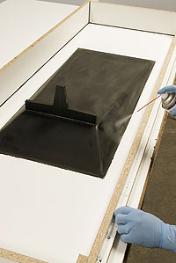  Step 1: Begin by applying any required mold-release to your mold. | 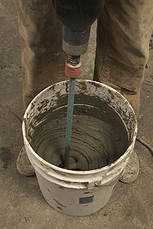  Step 2: Mix your face coat.
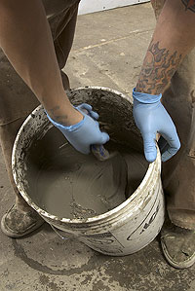  Step 3: Check the consistency. It should be similar to a milkshake. | 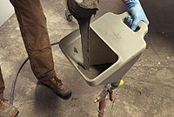  Step 4: Load the hopper with 2 to 3 quarts of the face-coat mix. Turn on the air and do a test spray on a piece of scrap. Set the air flow so the spray is just above “spattering.”  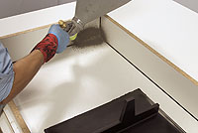
Step 5 - above right and below: Spray. Begin by spraying into the corner of what will be the front edge of your piece. Your spraying technique will be the primary factor in the quality of the finish. When spraying GFRC, you always want to spray into a corner and work your way back, spraying into the face coat you’ve already sprayed. By doing this, you compact the face coat and force out any air bubbles. This is the secret to a superior finish for GFRC.  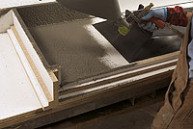 | 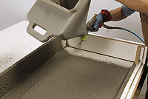  Step 6: Work in small areas, always being mindful to work your way back, spraying into the face coat you have already sprayed.  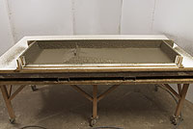  The mold, completely sprayed with the face-coat mix.
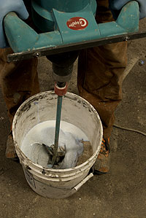  Step 7: Mix your vertical back coat. See the June/July issue of Concrete Decor for more details. | 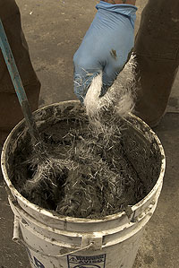  Add fibers slowly while maintaining a slow mixer speed.
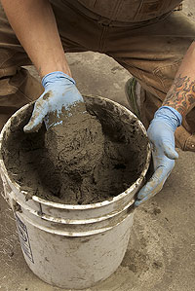  Check the consistency. It should be similar to thick cookie dough. | 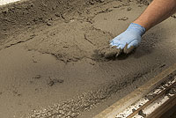  Step 8: Wait for the face coat to become stiff, but not dry, and then apply a thin application of the vertical back coat, an application also known as a scratch coat. Add a small amount of water, if needed, to thin the consistency of the back coat and make it more workable. Applying this thin scratch coat helps to prevent any air pockets from forming between the face coat and the back coat.
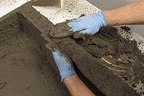  Step 9: Once the scratch coat has been applied, begin the application of the vertical back coat. Starting from the bottom, build the concrete up the vertical wall, holding the wall with one hand and using the other hand to smooth the top. You want to pull the mix over the top of the wall. This helps to keep the vertical back coat from pulling away or slumping.  If the vertical back coat does initially slump a bit, do not despair. Simply continue working your way around the mold. After a few minutes the section that was slumping should be firm enough for you to apply a second coat. | 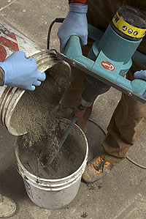  Step 10: Mix your self-consolidating back coat. Again, see the June/July issue of Concrete Decor for more information.
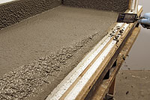  Step 11: Scrape the excess face coat off any walls where the self-consolidating back coat will be poured up to them. This will ensure consistent, accurate thickness in your piece. | 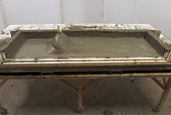  Step 12: Slowly pour the self-consolidating back coat into your mold. Work the concrete around the edges and corners to release any air pockets.
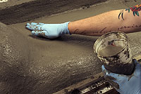  Step 13: Once the back coat has firmed up, you can smooth it to give it a more polished look. Simply mist or sprinkle the surface with water and smooth it with your hands. | 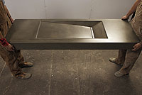  Step 14: Allow the concrete to cure for 24 hours, then  proceed with mold removal and finishing the concrete.
Brandon Gore operates Gore Design Co. LLC, based in Tempe, Ariz. He can be reached at info@goredesignco.com. Training DVDs, sink molds and mold-making supplies can be found at his supplier Web site, ConcreteApothecary.com. He also offers hands-on training workshops at GFRCworkshop.com
Part one of Gore’s GRFC process, including mix design recipes, can be found in the June/July 2008 issue of Concrete Decor

High-Performance Mix Design -- Understanding GFRC Mixes
I've heard it said that Las Vegas would not exist as we know it without glass-fiber reinforced concrete. If you took away all of the fountains, pyramids, fake ruins, boulders, castles, and building facades made with GFRC there wouldn't be much left to look at.
GFRC is a combination of fine aggregate, cement, water, polymer, chemical admixtures and glass fiber. The key to GFRC is the glass-fiber reinforcement. The fibers take the place of steel in a wet-cast mix. They allow GFRC to develop much higher flexural strengths than typical wet-cast concrete, allowing you to cast thinner, lighter sections and pieces.
There is endless debate among concrete countertop professionals about which is better, wet-cast or GFRC. I don't see either as better. If I were going for a look with a lot of exposed larger aggregate I'd wet-cast the piece, but if I were making an 8-foot ramp sink with a slot drain and a limestone-type look I'd use GFRC. I look at the project and decide what it needs to be. Sometimes it could be either, but sometimes one makes more sense than the other.
One of the main differences between the two is that you do not need a backup mold (on a sink or a drop-down edge) with GFRC, while you do need one with wet-cast. Another difference is the lack of larger aggregate in GFRC mixes.
GFRC concrete countertops and sinks typically consist of a sprayed-on face coat and a hand-placed fiber-reinforced back coat. This is known as "premix GFRC" - the fiber is mixed into the backing mix prior to placement. While the back coat in premix GFRC is typically hand-placed, it can also be sprayed with properly designed equipment. Larger GFRC producers use the "spray chop" method, which involves a specially designed gun that sprays cement slurry and chops AR (alkali-resistant) glass fiber, shooting both simultaneously into the mold.
You can also make self-consolidating GFRC pieces with no face coat. The fiber won't show as long as you don't polish the piece.
Ingredients and Their Functions
Cementitious binder:
The glue that holds things together.
Portland type I is fine, white or gray - the choice is based purely on aesthetics. Find a source and stick with it. CSA (calcium sulphoaluminate) cement will also work.
There are "all-in-a-bag" mixes, such as Fast Stone CW, produced and distributed by Ball Consulting Ltd. It contains white type I portland, Qwix cementitious additive and VCAS pozzolan. This mix features a 3-hour to 4-hour demold time.
Pozzolan:
You do not need to use a pozzolan in your GFRC mix. However you can make denser, stronger and greener GFRC when you use one. I've been using a pozzolan made from post-consumer glass bottles with great success.
Fine aggregate:
Most GFRC producers use gap-graded sand. "Gap-graded" means that the particles in a batch will fit through a screen with certain-sized gaps. A few smaller or larger particles might be mixed in. Sizes of sand used range from #30 to #60.
I use concrete sand in my GFRC. I screen out the particles larger than #30 and am left with a mix of sizes up to #60. At $20 per ton it's a bargain.
As long as the particles don't clog up the sprayer, just about any sound, inorganic sand will work to get the look you want.
Fibers:
AR (alkali-resistant) glass fibers are used in the back coat. You can use 1/2-inch or 3/4-inch fiber in your back coat. You will get slightly higher flexural strengths with the longer fiber.
There are two different types of AR glass fibers. One is 100 filaments per strand and the other 200 filaments per strand. The 100-filament fiber is better for the direct-cast method (with no face coat) because it hides better in the matrix. The 200-filament fiber is better for the backup mix because it is stronger.
There are also 1/8-inch and 1/4-inch dispersible fibers that work well in the direct-cast method in combination with the 100-filament products.
I would consult your AR glass fiber supplier to determine the best choice for the intended use.
Basic chemicals:
Your dosage of superplasticizer, also known as high-range water reducer, will depend on what you are casting. A self-consolidating back coat will require more than a hand-placed vertical back coat.
We will be using a polymer in our GFRC mixes.
Additional chemicals:
Nonchloride accelerating admixtures should not be needed as long as you cover the piece and keep it warm. Cement hydration slows to a crawl below 62 degrees. The solution is to cover the piece and add external heat if your shop is too cool. I use a PowerBlanket electric concrete-curing blanket to heat my GFRC to 120 F overnight.
Qwix is a cementitious additive that increases the strength development of concrete mixes. It is also a very powerful accelerator. I prefer to use a combination of portland cement plus Qwix rather than using straight CSA cement when I need a faster turnaround. I have fewer bags laying around, it is more economical than shipping CSA cement to the job site, and straight CSA cement is difficult to work with in warmer weather.
I would not recommend using a shrinkage-reducing admixture (SRA) with GFRC. The polymer already acts as a shrinkage reducer, making SRA use redundant with most polymers and possibly harmful when used with others.
Designing your GFRC mix
GFRC mixes are pretty basic. They are about a one-to-one ratio of sand to cement with water, polymer, fiber and chemicals. We'll keep it simple and look at a typical batch rather than using the volumetric method.
This batch will have a density of about 125 pounds per cubic foot. The total weight of the batch is 236 pounds, not including fiber. The yield:
- 236 ÷ 125 = 1.9 cubic feet
- Cement: 100 pounds
- Sand: 100 pounds
- Polymer: 10 pounds Forton VF-774, an emulsion with 51 percent polymer solids.
- Water: Given a 0.31 water-to-cement ratio, you need 31 total pounds. There is water in the polymer emulsion, so how much should you add?
You need to calculate the amount of water in your polymer. Forton VF-774 contains 51 percent solids and 49 percent water. You have 10 pounds of VF-774, and 49 percent of 10 pounds = 4.9 pounds.
Total weight of water to add to batch:
- 31.0 pounds (total water required) minus 4.9 pounds (water in the polymer) = 26.1 pounds (water we will weigh and add).
Remember you will also have to compensate for moisture if you are using sand with moisture in it.
- Water: 26.1 pounds.
- Superplasticizer: 3 ounces
Optimum 380 should be added at 3 ounces per hundredweight of cement. We have about 1 hundredweight (100 pounds) of cement in our example mix so we'll start with 3 ounces.
Add more as needed to maintain your water-to-cement ratio while achieving your desired of fluidity.
Fluidity per dosage of superplasticizer will vary with cement brand, cement type, aggregate size, aggregate shape, and fiber type and loading.
Finally ... Fiber: 7 pounds Fiber should be added at a rate of 3 percent of the 236.1-pound total batch weight (without it).
- 236.1 x 0.03 = 7 pounds
That's it. Simple math gets you quantities required for a specific project. For example: Say you need to cast a 4-foot by 8-foot slab that is 0.083 feet (1 inch) thick.
- 4 x 8 x 0.083 = 2.66 cubic feet required ÷ 1.9 (cubic feet per batch) = 1.4 batches required.
How you determine how much you mix at a time depends on your capacity.
Mixing GFRC
The goal when mixing GFRC is to end up with a thoroughly homogenized mix without beating up the fiber. The fiber is glass and will break down.
The optimum mixing method for GFRC is a high-shear mixer. A small high-shear mixer example would be a heavy-duty drill and paddle. Drill and paddle mixers work well for small face-coat batches with no fiber. Much larger-capacity specially made high-shear mixers are available to mix larger quantities of back coat at a time.
Another option is to mix your back coat in a barrel mixer or a vertical shaft mixer. I can mix 250 pounds of back coat at a time in my small barrel mixer and about 800 pounds of back coat at a time in my Imer vertical shaft mixer.
Mixing without getting cement lumps is a little tricky.
Add all of the sand, some of the water and one fourth of the cement, and mix it.
Gradually add the rest of the cement and water. Hopefully you will not get lumps of cement that don't break up.
Once this is fully mixed, add the fiber. Do not overmix the fiber, because you will break it up, rendering it useless. I would say that with my mixers, 1 minute of mixing time after the fiber is added gets it mixed in.
Green GFRC mix design
I've heard arguments stating that GFRC is green because it uses less material than wet-cast. That's a tough argument to make due to the 50 percent portland cement content of GFRC verses the 25 percent cement content of wet-cast concrete. We all know that every pound of portland produced equals one pound of carbon dioxide released.
There are steps you can take to make greener (always a relative term) GFRC. Here's a sample recipe.
- Cement: 80 pounds
- Bottle-glass pozzolan: 20 pounds
- Glass sand: 100 pounds
- Polymer: 10 pounds Forton VF-774
- Water: 26.1 pounds (0.31 water-to-cement ratio, or 31 total pounds in this case, minus the 4.9 pounds of water in the polymer. The pozzolan is counted as cement. For more explanation, see the discussion and numbers in the "Designing your GFRC mix" section.)
The neat thing about this mix is the bottle-glass poz and the glass sand all come from used bottles, giving this mix about 60 percent post-consumer waste product content.
Mark Celebuski is a consultant to the countertop and precast concrete industries. He can be reached at mark@trinic.us.
More about polymer
A data sheet about polymer, from Ball Consulting Ltd.:
More about chemicals
www.concretecountertopsupply.com
www.ball-consulting-ltd.com
www.basf-admixtures.com
www.euclidchemical.com
www.fritzpak.com
www.grace.com
www.negamerica.com
More about fiber
www.nycon.com
www.ball-consulting-ltd.com
www.negamerica.com

